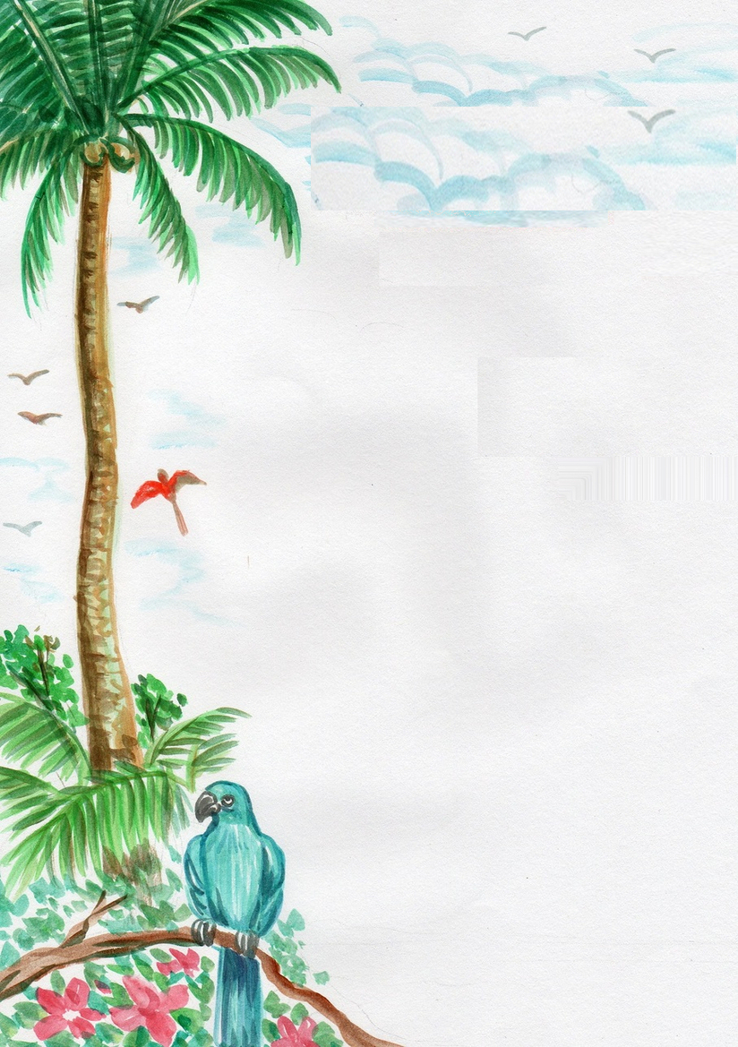

**2 Toasts P 60**

*With Butter & Jam*

**2 Eggs & 3 Slices Bacon P 180**

*With Butter & Jam & 2 Toasted*

*Bread Slices*

**2 Eggs & 3 Slices Bacon P 200**

*With Home fried Potatoes & Butter & Jam*

**Muesli P 120**

*With Milk or Yoghurt*

**Cornflakes with Milk P 80**

**Fruit plate small P 150**